BRIANNA HUPP PHOTOGRAPHY
Canvas Print Pricing
These canvases are printed with UV-protected latex inks. Museum-Grade Canvas. Printed on a specially-coated, archival-grade, poly-cotton canvas. Handcrafted, 100 percent pinewood frames sourced from sustainable forests. Prints arrive ready-to-hang with pre-installed metal hooks. Every print has reinforced backing so they are guaranteed never to sag.
Single Canvases
Recommended
5 x 7 $30
8 x 10 $40
16 x 20 $60
20 x30 $80
Square
8 x 8 $35
10 x 10 $45
16 x 16 $50
24 x 24 $70
30 x 30 $90
45 x 45 $295
Small
12 x 8 $50
11 x 14 $50
12 x 12 $50
12 x 18 $50
Large
16 x 20 $60
18 x 24 $65
24 x 36 $80
30 x 40 $85
40 x 40 $125
36 x 54 $315
Additional:
*Minimum purchase of $40.
Sawtooth hanger- $3.99 each
Dust cover back- $9.99 each
Lamination- $4.99 each
Wall Display Packages
3 Piece: 1- 16” x 24”
36” x 42” Display 1- 24” x 16”
$130 1- 18” x 12”
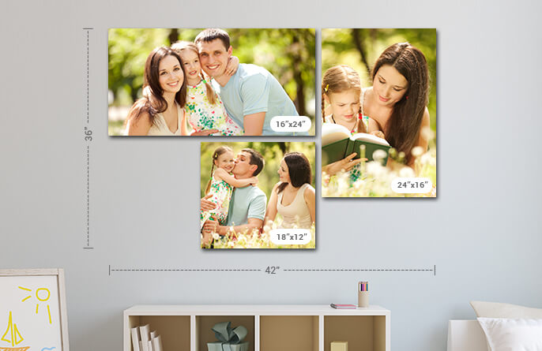
3 Piece:
26” x 40” Display 1- 26” x 26”
$135 2- 12” x 12”
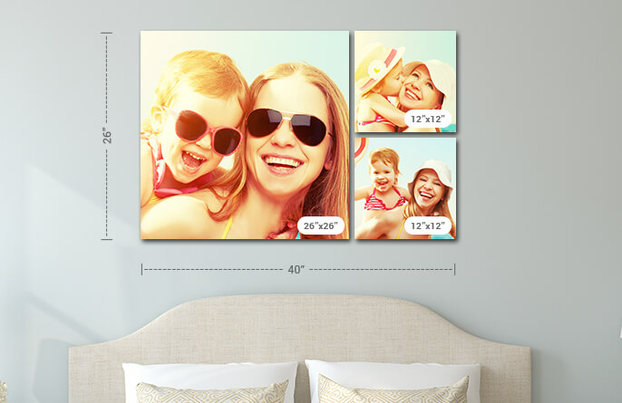
3 Piece:
30” x 64” Display 3- 30” x 20”
$195
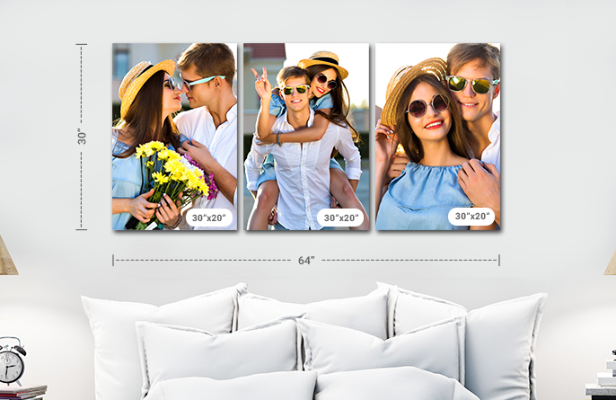
4 Piece: 1- 25” x 16”
25” x 36” Display 1- 11” x 18”
$180 2- 12” x 18”
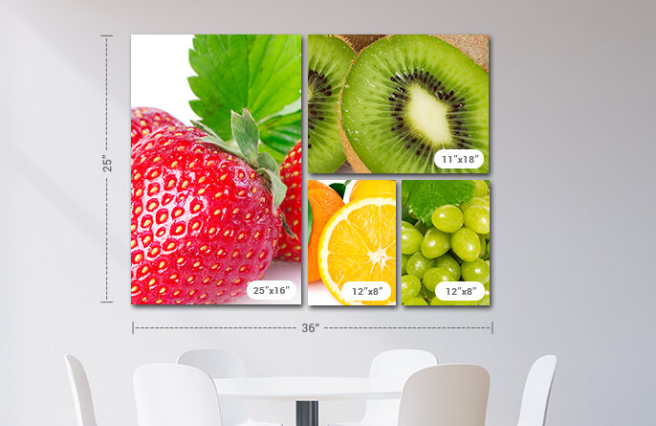
4 Piece:
32” x 32” Display 4- 15” x 15”
$160
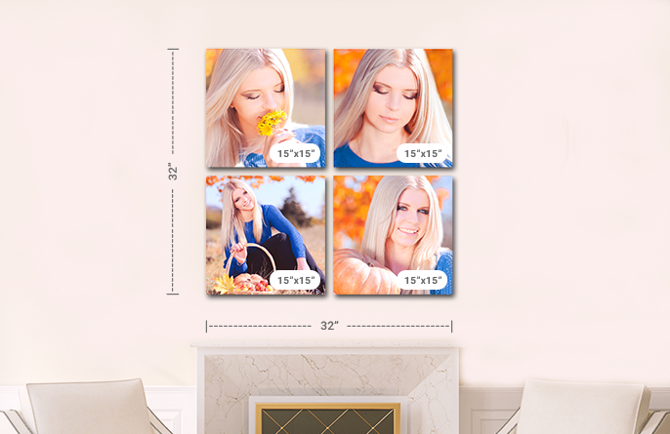
4 Piece:
34” x 35” Display 1- 34” x 20”
$220 3- 10” x 13”
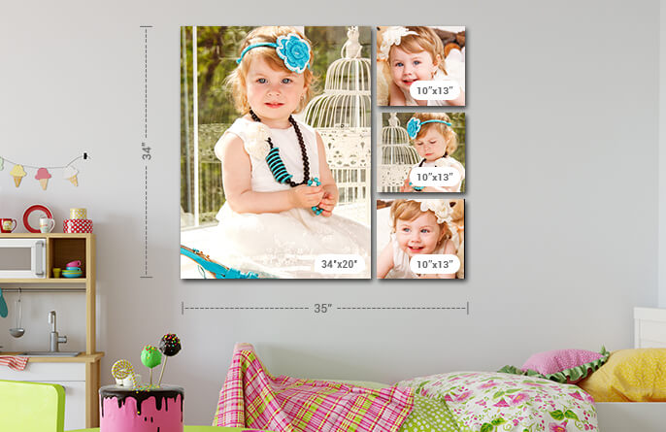
5 Piece:
24” x 50” Display 4- 11” x 11”
$230 1- 24” x 24”
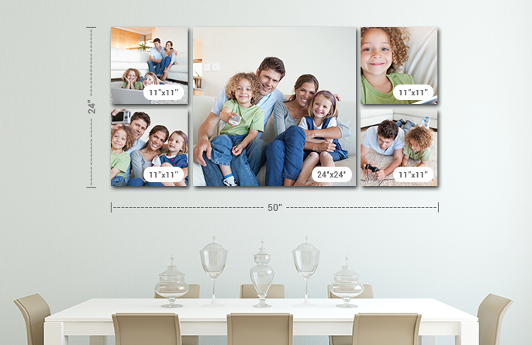
5 Piece: 1- 15” x 24”
37” x 54” Display 2- 20” x 13”
$275 2- 16” x 11”
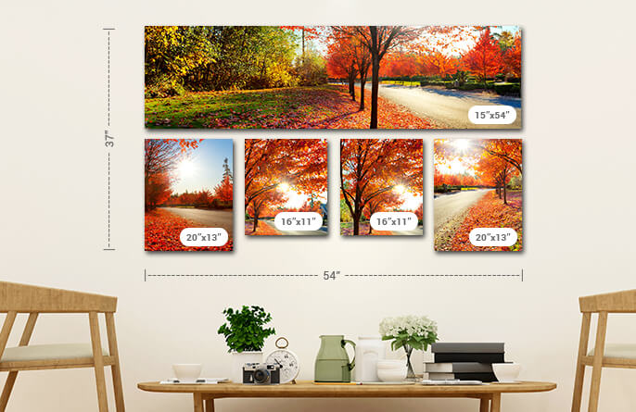
7 Piece: 3- 10” x 12”
32” x 48” Display 2- 15” x 20”
$260 1- 18” x 12”
1- 12” x 12”
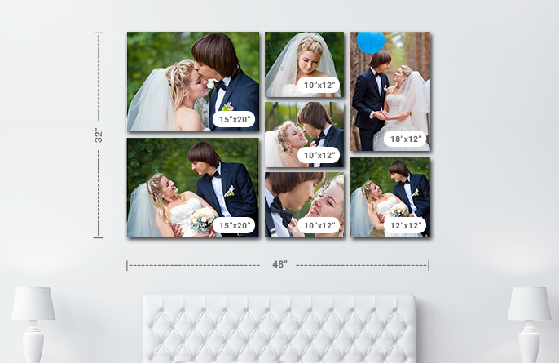
7 Piece:
44” x 46” Display 4- 10” x 14”
$330 3- 20” x 14”
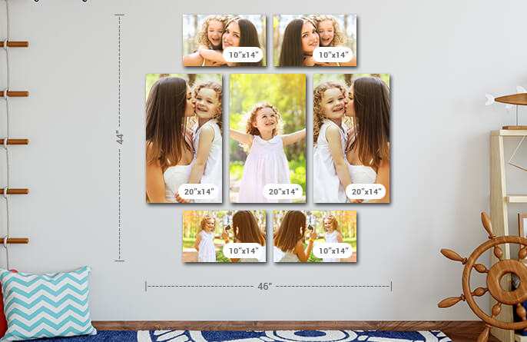
10 Piece: 1- 16” x 12” 1- 20” x 16”
46” x 72” Display 1- 11” x 16” 1- 24” x 16”
$310 2- 10” x 12” 1- 18” x 12”
2- 12” x 12” 1- 16” x 20”
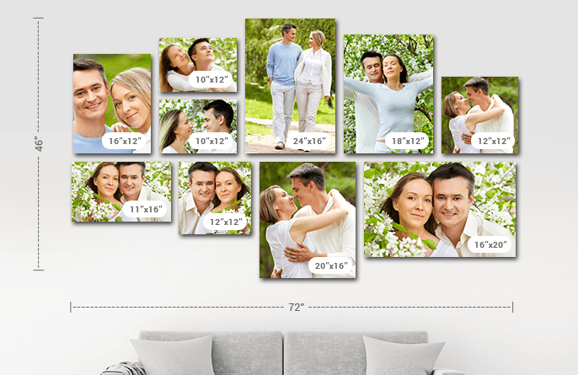

Additional:
Sawtooth hangers- $15.99 per set
Dust cover backs- $29.99 per set
Laminations- $19.99 per set
Brianna Hupp Photography
Hexagonal Canvas Pricing
Horizontal Displays
Single- 8x5” x 10” $40
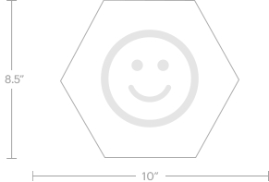
Bundle of 3- 13.75” x 27” $100
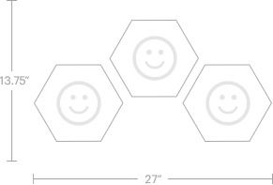
Bundle of 3- 19” x 18.5” $100
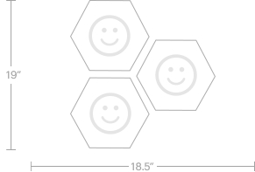
Bundle of 4- 19” x 27” $130
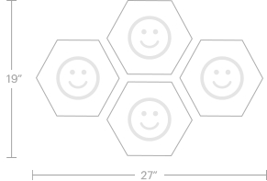
Bundle of 5- 19” x 27” $160
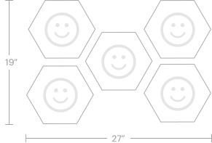
Bundle of 5- 22.25” x 27” $160
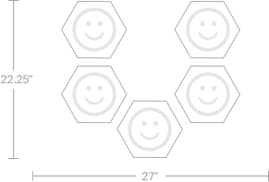

Bundle of 7- 27.5” x 27” $225
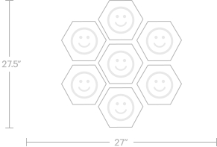
Bundle of 8- 27.5” x 27” $265
Bundle of 10- 40” x 27” $330
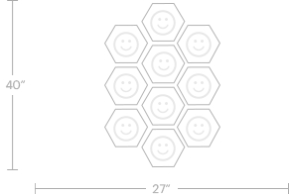
Vertical Displays
Single- 10” x 8.5” $40
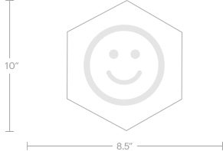
Bundle of 3- 17.5” x 19” $100
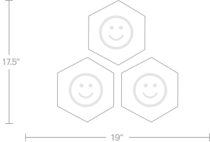
Bundle of 4- 27” x 19” $130
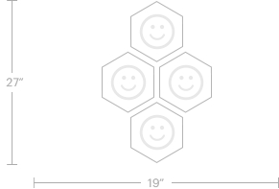

Bundle of 7- 27” x 29.5” $225
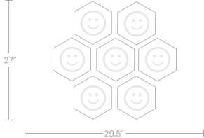

Bundle of 8- 27” x 29.5” $265
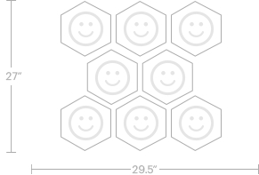
Bundle of 10- 27” x 40” $330
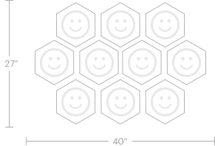

Brianna Hupp Photography
Photo Blanket Pricing
Woven Blankets
Made from 100% cotton. Machine wash in cold water using mild detergent and gentle cycle only. Do not bleach or tumble dry. Packaged in a protective box.
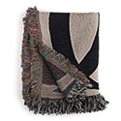
SIZE PRICE
50” x 60” $105
60” x 80” $145
Fleece Blankets
The soft fleece is 100% polyester and easy to care for. Printed in the USA. Packaged in a grey poly bag.
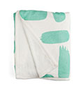
SIZE PRICE
50” x 60” $105
60” x 80” $125
Sherpa Blankets
These silky-soft 100% polyester fleece Sherpa blankets are even warmer than they look. Machine wash separately in cold water. When drying, use delicate cycle and tumble dry on low. Do not bleach. Do not iron, press with heat or dry clean.
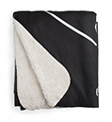
SIZE PRICE
50” x 60” $115
60” x 80” $145
Brianna Hupp Photography
Photo Board Pricing
If you want your printed images to be the talk of the town and truly stand out amongst the others, all you need is a photo board to add to the charm of the picture. Mounted picture boards are the latest stylish choice for displaying your choice images in a unique way. What better way to enjoy and display the beauty of your favorite image, than by having the print mounted on a proper photo board! It is a great way to make your image the centre of attention.
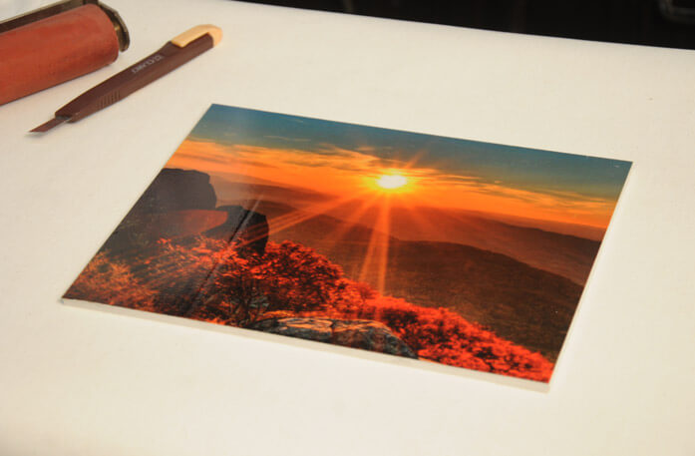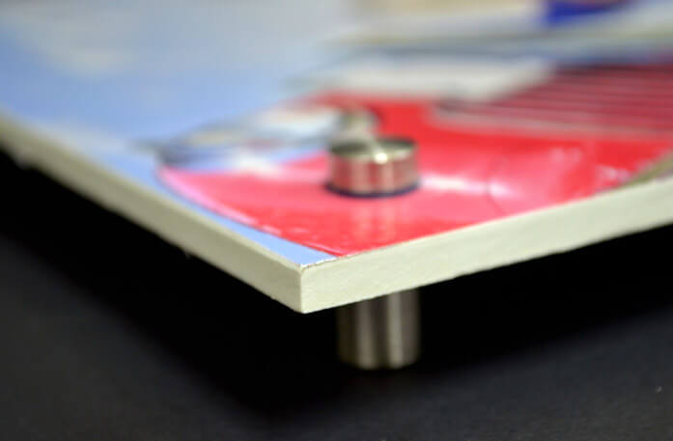
Recommended
8 x 10 $35
18 x 12 $50
16 x 20 $60
30 x 30 $130

Square
8 x 8 $35
10 x 10 $45
12 x 12 $55
16 x 16 $70
20 x 20 $95
24 x 24 $110
Small
12 x 8 $50
11 x 14 $50
Large
16 x 24 $60
18 x 24 $65
20 x 24 $70
24 x 30 $105
Brianna Hupp Photography
Premium Quality Photo Print Pricing
*Minimum purchase of $26.
SIZE PRICE
4 x6 $10
5 x 7 $14
6 x 8 $20
8 x 10 $26
8 x 12 $30
10 x 13 $34
11 x 17 $42
12 x 8 $50
16 x 20 $62
Other available luxury print items available. Inquire for information on:
-Split Canvases
-Tabletop Canvas Prints
-Desktop Plaques
-Magnets
-Photo Mugs
-Magic Mugs
-Travel Mugs
-Beer Mugs
-Ornaments (Canvas, Metal, Porcelain, Wooden)
-Wall Calendars
-Desk Calendars
COMING SOON:
-Tapestries
-Notebooks
-Water Bottles
-Acrylic Books
-Phone Cases
-Mouse Pads
-Puzzles

